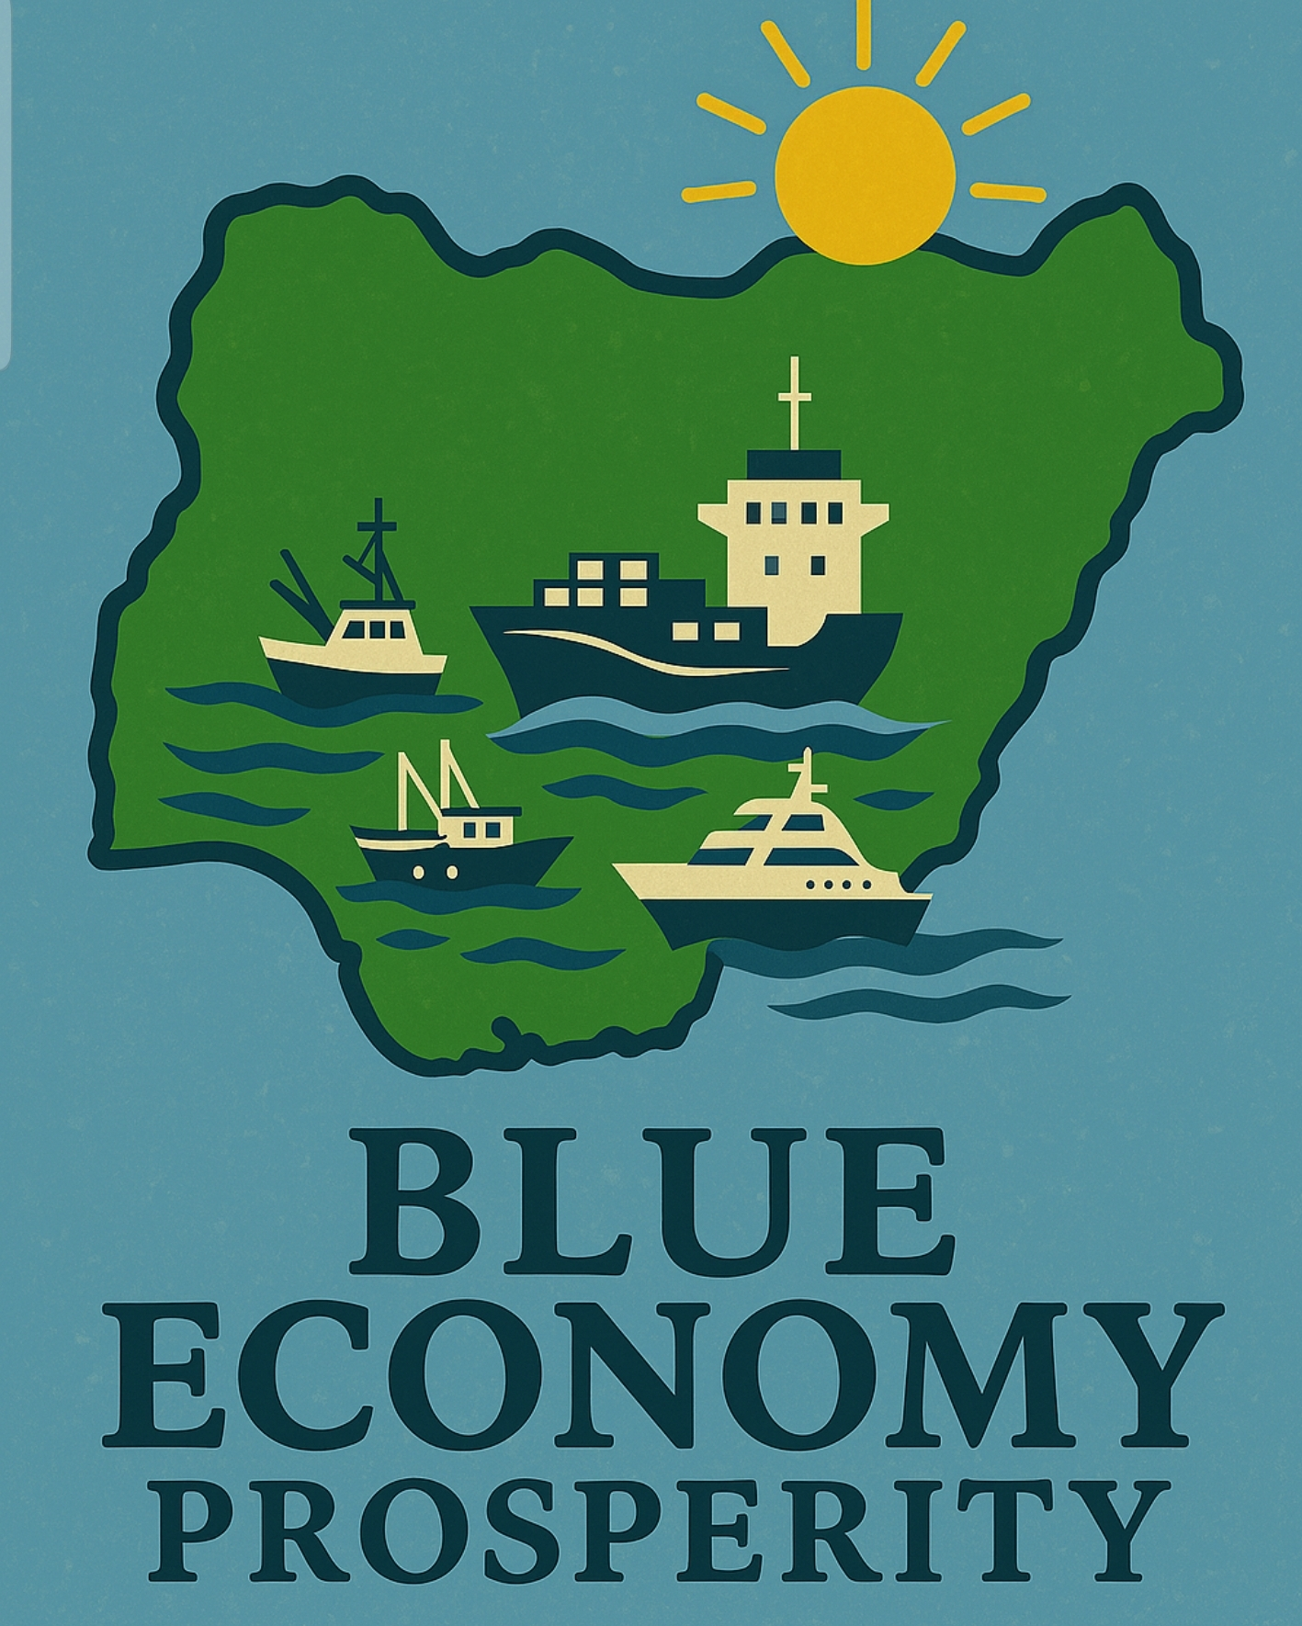
THE $1.5 TRILLION PLUS GDP NIGERIAN BLUE ECONOMY CONFERENCE - OPPORTUNITY FOR NIGERIA’S PROSPERITY

INTRODUCTION:
The remit of those who advised on the new National policy on Blue Economy was to produce a policy document on a Nigeria Blue Economy for the Marine subsector (a sub-sector) of the economy. And to a considerable degree the document they came up with – National Policy on Blue Economy met the expectations and satisfaction of the client - Ministry of Marine and Blue Economy. But is this the best version of the Blue Economy for Nigeria considering where the economy is?

What is clear and without question is the Nigeria economy has been under pressure for too long thus requires a significant amount of inspiration that could help it deal with the most chronic critical challenges it faces - unemployment, transportation infrastructural deficit, low productivity, limited numbers of centers of economic growth and sustainable development. For Nigeria at this time and place the Blue Economy offers the platform to meet these fundamental challenges for sustainable growth and development.

This Conference provides a forum for stakeholders, professionals, Economists and financial experts, policy makers, Legislators and government officials to discuss the $1.5 TRILLION PLUS NIGERIAN GDP opportunity that will change the economic landscape of Nigeria for ever.

RATIONALE FOR A BLUE ECONOMY MAXIMALIST AGENDA:
With the Nigerian GDP hovering around $350 and $450 billion in the last few years for a population of over two hundred and twenty million projected to become the third largest in the world in a short while:- Build TEN ultra modern new ports along the Nigeria Atlantic Coast as new centers of economic growth with close industrial clusters, SEZs and technology hubs, new cities.
Even a 20–25% increase in current port throughput, combined with sectoral diversification, could ripple across GDP metrics. The multiplier effect in jobs, income, and investment could be huge if governance and policy coherence align.
- Nigeria has a 853 km coastline, underutilized for national productivity.
- Existing ports are overburdened; regional competitors have outpaced Nigeria in maritime logistics.
- Ten new ports would dramatically increase Nigeria’s cargo handling capacity. This could:
- Attract regional transshipment business currently going to hubs like Lomé and Tema.
- Enable exports of value-added goods (not just raw commodities) via efficient logistics.
- Create jobs in port operations, logistics, customs, and maritime services.
- The African Continental Free Trade Area (AfCFTA) unlocks regional demand that Nigeria must meet or risk marginalization.
Projected Estimated Cost details (based on current global transactions):
- Construction of 10 Deep Sea Ports $60–$80 billion Includes dredging, quays, smart tech, customs zones
- Transport Infrastructure (Roads, Rail, Inland) $40–$60 billion 10,000+ km corridors, bridges, depots, waterway upgrades
- SEZs & Industrial Clusters $30–$45 billion Power, water, land, incentives, industrial parks
- Marine & Offshore Energy Development $25–$35 billion Wind farms, blue hydrogen, gas pipelines, R&D
- Services, Innovation & Human Capital $8–$12 billion Maritime universities, research institutes, startups
- Digital Port Systems & Surveillance $5–$8 billion AI-driven port management, coastal security tech
- Construction of 5 Strategic Airports $15–$20 billion Terminals, runways, cargo infrastructure, inland access
- Environmental & Coastal Resilience Fund $4–$6 billion Mangrove restoration, eco-tourism, sustainability programs
- Institutional Strengthening & Governance $2–$4 billion Coordination bodies, legislation, PPP frameworks
Total Estimated Investment: $190–$270 billion (spread over 5–7 years)

FINANCING STRATEGY:
What are the realistic financing strategy available to the country for this considerable investment?
HISTORY:
As of the first quarter of 2025, Nigeria’s total public debt stands at approximately ₦149.39 trillion (about $97.2 billion). Here's a breakdown of what that looks like:
Nigeria’s Debt Snapshot (Q1 2025)
| Category | Amount (₦) | Amount (USD) | Share of Total Debt |
|---------------------|------------------|------------------|---------------------|
| Domestic Debt | ₦78.76 trillion | $51.26 billion | 52.7% |
| External Debt | ₦70.63 trillion | $45.9 billion | 47.3% |
| Total Public Debt | ₦149.39 trillion | $97.2 billion | 100% |
B) TRENDS & INSIGHTS:
- The debt increased by ₦4.72 trillion from the previous quarter.
- Compared to Q1 2024, it rose by ₦27.72 trillion, a 22.8% year-on-year jump.
- Nigeria’s debt-to-GDP ratio is now around 65%, exceeding the Debt Management Office’s ceiling of 40%.
- The country spent ₦13.12 trillion on debt servicing in 2024 alone – not a good indicator
C) CREDITORS:
- Multilateral lenders: World Bank ($18.3B), AfDB ($3.5B), IMF (recently repaid $406M)
- Bilateral lenders: China ($5.16B), France, Germany, Japan
- Commercial lenders: Eurobond holders ($17.32B)
D) CONCERNS:
Experts are raising alarms over the lack of visible infrastructure improvements despite rising debt. There’s also growing pressure on revenue generation, the alarming issue of extreme low productivity with debt servicing costs often exceeding government income.
E) SOLUTION:
It is this concerns that further make the infrastructure centric maximalist interpretation of the country’s sustainable Blue Economy a fundamental solution. Nigeria’s inadequacy of roads and rails networks is so bad that it is laughable. The ten new ports connected by new rails and roads from this corridor going hinterland with estimated 10,000 kilometers of new roads and commensurate rails for goods delivery into the hinterland. The new five airports serving international investors, tourists into the corridor would require new hotels and recreational facilities to serve these new centers of economic growth.
ALTERNATIVE FINANCING:
This conference will rightly consider alternative financing anchored on Nigeria’s vast untapped hydrocarbon reserves particularly Gas for financing that would not have any attending effect on the concerning debt profile. Actually, the international concerns about whether Nigeria can manage this is condescending to say the least. That is not to say one is ignorant of the pervading culture of corruption. The establishment of a twenty first century autonomous entity, technology driven Nigerian Blue Economy Commission NBEC should ensure transparency and sustainable global practices.
OBJECTIVES:
- Illustrate the importance of the Blue Economy to the Nigerian economy going forward
- Underline the correctional ability of a Nigerian Blue Economy to correct the inadequacy of the country’s transportation infrastructural deficit
- Demonstrate how the Blue Economy can solve fundamental critical economic problems facing the country
- Highlight the importance of establishing a modern administrative entity NBEC to oversee the overall micro management of the Blue Economy for sustainable development of Nigeria.

CONTEXT/CONTENT AND METHODOLOGY:
The premise of this conference is based on the simple logic that the current monocentric Nigerian economy is not sustainable and would continue to fail its people, Africa and the global metrics for sustainable growth and development unless a completely new dynamic is introduced. That a maximalist interpretation of the country’s sustainable Blue Economy offers the country the unique opportunity to confront most of its headline economic challenges – low productivity, chronic immersed unemployment, transportation infrastructural deficit, limited numbers of centers of economic growth and sustainable development in a short to medium term. The conference will elaborate on these factors with the help of seasoned academia, some key players in the economy will make contributions. The establishment of a Nigerian Blue Economy Commission NBEC – a new autonomous body staffed with officials with international education, technology savvy and professional experience will assuage concern over the capacity to manage a complex assignment that includes but not limited to administration, advance planning, data collection and processing, financial intermediation, monitoring and enforcement of standard and procedure, spatial planning etc. The outcome of this conference will be immediately made available to the highest level of governments in the country for execution.
LEGISLATIVE REQUIREMENTS:
There is a necessity for clear legislation for these initiatives that would actually decide the fate of a sustainable Nigerian Blue Economy. Stakeholders need to know their roles, investors need to be assured their investments are secured and modalities for repatriation of their profits and capital are properly enacted into law in compliance with acceptable international norms.
PARTICIPANTS:
FEDERAL LEGISLATORS, PROFESSIONALS, POLICY MAKERS, MDAS, FEDERAL MARITIME OPERATORS, LITTORAL STATES, ACTIVE STAKEHOLDERS, LOCAL AND INTERNATIONAL INVESTORS, DEVELOPMENT PARTNERS, MULTILATERAL INSTITUTIONS, MEDIA, POLICY MAKERS, LOCAL AND INTERNATIONAL FINANCIAL INSTITUTIONS.
PARTICIPATION DETAILS:
Development Partners: $5,500.00
Multilateral Financial Institutions: $5,500.00
International Financial Institutions and Investors: $1,500.00
Professional Bodies: N2,500,000.00
Littoral States: N5,750,000.00
MDAs: N2,500,000.00
Institutional Stakeholders: N2,500.000.00
- NOTE: Each entity is allotted 2 official representation with 4 for littoral states - entitled to full access and participation, coffee break and lunch for the two day event.
Media: FREE participation (maximum 2 person per entity) subject to advance accreditation at least two weeks before the event.
SPONSORSHIP: The conference will welcome certain sponsorships like the sponsorship of the delegates participation of up to twenty members of the National Assembly, the Honourarium, the welcome dinner (please call for details). This would attract special commendation along with higher corporate visibility during and post event at what will be the first of its kind conference in the country.
BANKING DETAILS: Guaranty Trust Bank, $0427350529 ; N0631247749 ; INALFE CITY SERVICES.
Email address: alfecityi@gmail.com
Phone number: ±2347051423739
VENUE: IBOM HOTEL AND GOLF RESORT, UYO, AKWA IBOM STATE, NIGERIA
DATE: 28 & 29 OCTOBER, 2025
ABOUT ALFE CITY INSTITUTION AND THE NIGERIAN BLUE ECONOMY:
The first Alfe City Institution outreach proposing Blue Economy Concept to the then Ministry of Transportation was in March, 2020; then organized The Nigeria Blue Economy Stakeholders Conference 15-17 February, 2022 in Lagos – this included the United Nations Global Compact Sustainable Ocean Business Action Platform; then the Niger Delta Blue Economy Investment Forum 15-17 November, 2022, Uyo, Akwa Ibom State; Alfe City Institution was coopted into the Expanded Partnership Committee on Blue Economy in Nigeria in recognition of its contributions; then the Nigerian Blue Economy Discovery Conference 27-30 November, 2023, LAGOS; the SUSTAINABLE NIGERIAN BLUE ECONOMY – ECOSYSTEM CONFERENCE - 26-28 NOVEMBER, 2024 Port Harcourt; the SUSTAINABLE NIGERIAN BLUE – STRATEGY CONFERENCE, July 2025 also Port Harcourt

alfecity.com

